IDEAL COLLEGE OF ARTS AND SCIENCES (A)
(A.P. Govt., Aided., Autonomous & NAAC B++)
Dr. P.V.N. RAJU VIDYAPRANGANAM
Samalkot Road, KAKINADA
East Godavari Dist
Andhra Pradesh

Department of Commerce

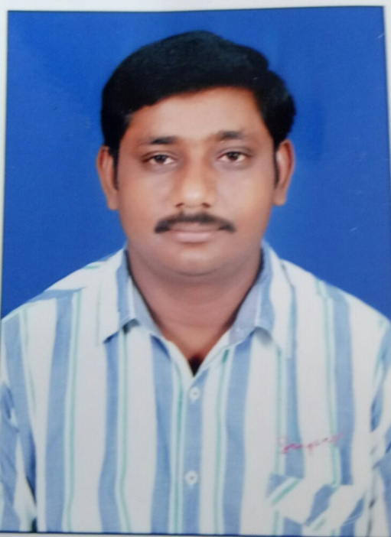

Profile

- Name : Y.R.L Chowdary
- Designation and Place of work : Lecturer in commerce
Ideal College of Arts & Sciences (A)
Kakinada-533003
A.P., INDIA.
- Date of Birth : 10-05-1981
- Nationality : Indian
- Mobile no : 9959235555
- E-mail : ramababuyaramati@gnail.com
- Address for Correspondence : Y.R.L Chowdary
Lecturer in commerce
Ideal College of Arts & Sciences,
Kakinada – 533 003, A.P., India.

- Details of Educational Qualifications:
Sl. No. | Course | University | Year | Specialization
1 | M.com | Andhra University | 2003 | Cost & management accounting
2 | M.B.A | NagarjunaUniversity | 2011 | Finance

- Experience:

Sl.No | Designation | College | Date of Joining | Experience
1 | Lecturer | V.S.M College, Ramachandrapuram | 1-07-2003 to 2015 | 12Years
2 | Lecturer | Ideal college of arts and sciences | 12-027-2015 | 3 years

- Regional/ State/National level Conferences/Workshops/Seminars

National workshop-01
Seminars-03

- Administrative Experience:
Admissions, discipline committees etc…

